\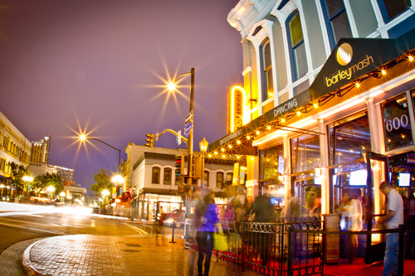
Please join us for an evening of cocktails on Monday, October 24th at 8pm-12am
600 5th Avenue, Gaslamp District
There will be Hors D’ oeuvres & Food Stations
If you are attending the ASA Anniversary Leadership dinner, stop by afterwards, we will be going until late.
We hope to see you there!
Hosted By:

